2019 Sponsorship Program
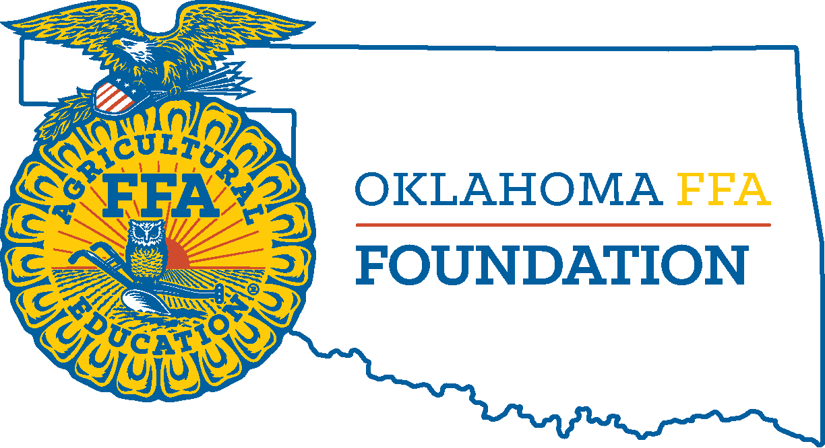

Title Sponsor – Platinum Level $50,000+
XDevon Energy
XExpress Employment Professionals
XMasonic Charity Foundation
Oklahoma Ford Dealers
PSO - Public Service Company of Oklahoma

Title Sponsor – Diamond Level $25,000+
XAFR Insurance
XBlue and Gold Sausage
Farm Credit Associations of Oklahoma
McDonald’s Southern Plains Operators Assoc. check
NextEra Energy
Oklahoma Farm Bureau
Sonic, America’s Drive-In
TransCanada

Gold Level Sponsor $17,500+
The Craig Foundation
Noble Research Institute
Trusted Choice – Independent Insurance Agents of Oklahoma

Silver Level Sponsor $10,000+
Blue Cross Blue Shield
Cherokee Nation
Chickasaw Nation
Choctaw Nation of Oklahoma
Cimarron Trailers
Ditch Witch
Enel Green Power
ITC Holdings Corp.
Livingston Machinery
Mahindra North America
Oklahoma Department of Wildlife Conservation
Oklahoma FFA Alumni Association
Oklahoma FFA Foundation Presidents Club
OPAL – Oklahoma Pipeline Awareness Liaison
P&K Equipment
Pioneer Cellular
Plumbers & Pipefitters Local 344 & 430 Training Centers
SandRidge Energy
Warren CAT

Bronze Level Sponsor $5,000+
Atwoods
Blue Mountain Equipment & STIHL
CEV Multimedia
Dorada Foods
Eddie & Barbara Smith
Eskimo Joe’s
Lopez Foods
Matthew 25:40 Mission Scholars – Wes & Lou Watkins
Nelson & Helen Taylor
Oklahoma Wheat Research Foundation
Oklahoma City Convention & Visitors Bureau
Oklahoma LP Gas Research, Marketing and Safety Commission
Oklahoma State University – CASNR
ONEOK
Shawnee Milling Company
Steve & Merrie Lynn Vaughan
TSET
Western Equipment LLC

Presidential Level Sponsor $2,500+
AARP Oklahoma
APEX Clean Energy
Armstrong Bank
Army ROTC
Arvest Bank
Associated Electric Cooperative
BancCentral
BancFirst
Brady Womack/B-5 Show Supplies
Cattlemen’s Choice Insurance
Chapman Ranch
CM Trailers
Davis Farms
Diamond Hats
Drs. Eric & Cheryl DeVuyst
Gilbert & Sons Trucking
Hanza’s Soldier Xpress
Int’l Union Operating Engineers
Koch Industries
Livestock Nutrition Center
Love’s Country Stores
Martindale Feed Mill
Muscogee Creek Nation
OAETA
Oklahoma Association of Electric Cooperatives
Oklahoma Beef Council
Oklahoma CareerTech Foundation
Oklahoma Land Lady
Oklahoma Pork Council
Oklahoma Steel & Wire
Oklahoma Wheat Commission
T&D Meats
The Poultry Federation

